City of Barnwell Mosquito Control Map
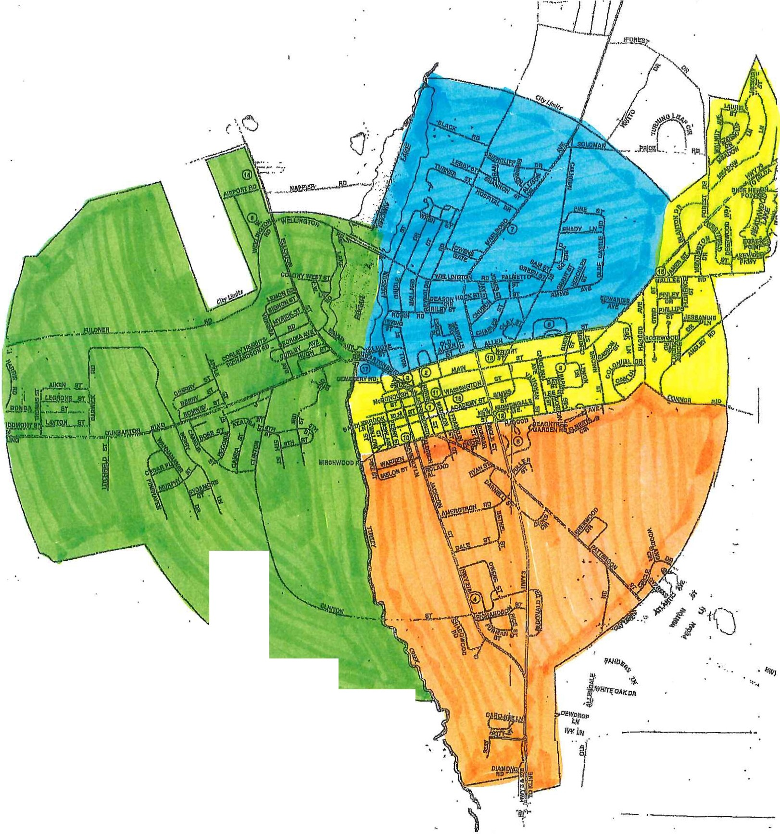

·

"'''-......_... ·--. -·

Dates for Mosquito Control Zones

- Dates in May are Tuesdays and Thursdays. All dates after May 28 for spraying are on Tuesdays and will be sprayed between the hours of 4pm-8pm.
- After May 28, if inclement weather occurs spraying will occur the Thursday after the assigned date.
- If any of the zones require additional Mosquito Control, the times will be updated on The City of Barnwell’s Website: www.cityofbarnwell.com

